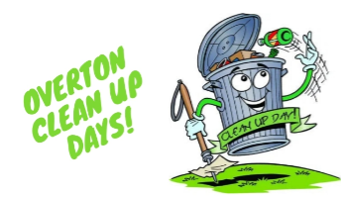

FRIDAY, MARCH 24 8 A.M. – 4 P. M.
SATURDAY, MARCH 25 8 A.M. – 3 P.M.
OR UNTIL DUMPTERS ARE FULL

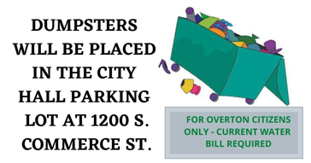

PROHIBITED ITEMS
TIRES, CAR BATTERIES, OIL, LIQUIDS, HAZARDOUS WASTE, OIL-BASED PAINT, (DRIED
LATEX PAINT IS ACCEPTABLE) REFRIGERATORS & AIR CONDITIONERS

